Gas Laws Quiz Topics List

Conversions:

Temperature conversions: Celsius to kelvin and kelvin to Celsius. 0°C = 273°K

Pressure conversions: 1atm = 14.7psi = 760torr = 760mmHg = 101.3kPa

Conceptual understanding: When all other things are held constant, what happens:

To the pressure when the temperature is raised/decreased?

To the pressure when the volume is raised/decreased?

To the temperature when the pressure is raised/decreased?

To the temperature when the volume is raised/decreased?

Graphing:

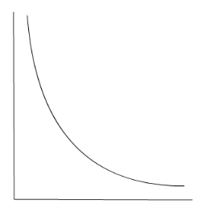Inverse relationship: one thing increases causing another thing to decreases.

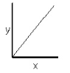

Direct relationship: one thing increases causing another thing to increase.

Mathematical relationships: Avogadro’s hypothesis.

1 mole of gas occupies 22.4L of space at STP.

STP: Standard Temperature and Pressure.

Standard Temperature: 0°C

Standard Pressure: 1atm.

With this information, you can solve for R (the ideal gas constant) using the ideal gas law: PV=nRT.

See the “review packet” on school wires under chapter 14: gas laws for practice problems for the combined gas law and the ideal gas law. *Omit problems 5 and 7 of the first section. These problems give the mass of a gas. You will not be responsible for this.

**Remember:** all temperature in kelvin, all pressure in kPa and all volume in liters.

Combined gas law: P1V1/T1=P2V2/T2.

You are given pressure, temperature and volume of a gas (P1, V1 & T1). If two of these things change, solve for the third variable.

Ideal gas law: PV=nRT

R is the ideal gas constant. R=8.31kPa L/mol K

Given 4 of the 5 variables, manipulate the equation and solve for the unknown variable. Make sure to answer all questions with the correct units of measure.

Example: A sample of 3 moles of oxygen gas is at STP. What is the volume of the gas?

3g = 0.09375mol.

P = 101.3kPa

V = ?

n = 3 mol

R = 8.31 kPa L/mol K

K = 273°K

V=(nRT)/P

V = 67.2L

Dimensional Analysis: Convert units of measure using fractions.

Put the known over one. Use “reference equations” to create fractions.

Cancel out units and solve for the new value and unit.